# TRACKING STUDENTS ON PLACEMENT

This user manual is for the placement team to be able to check all the important information about the students who are in a placement currently. Placement team members should have the ability to view all the necessary details about the students who are currently in their placement programme.

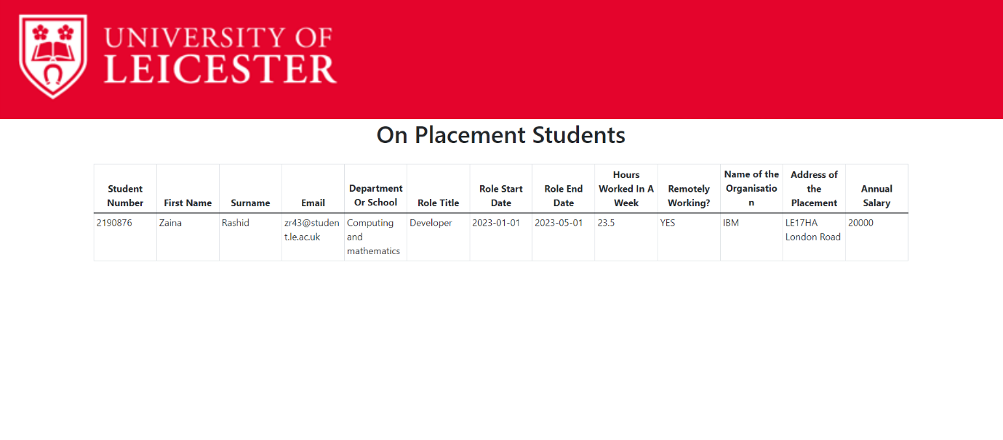

As shown in the image, this table will only display students who are currently in a placement from the database of all students. This feature will allow placement team members to easily view students who are currently enrolled in their program without having to comb through an extensive database of students.

The following details are included for each of the placement students:

The student number, their first name, their last name, their student email address, their department/school of study, their placement role title, their role start date, their role end date, the number of hours they work in a week, whether they are remotely working, the name of the placement provider, the address of the placement, and their annual salary.

By Moaz and Zaina